Ling 446: English Phonology  
Term Project  
Dan Jinguji

# Australian Diphthongs: A Diachronic View with a Nod to Accommodation

This is the examination of the diphthongs of a native speaker of Australian English who has lived on the West Coast of the United States of America for almost half her life.

## Background

An oft-cited book by Mitchell and Delridge (Wells 1982, Horvath 1985, Cox and Palethorpe 2001) characterizes Australian English has having three sociolects: Cultivated, General, and Broad. The Cultivated lect is closest to RP. The Broad lect is the stereotypical Australian dialect. It is characterized as being non-rhotic, having the trap-bath split and shifted diphthong, and not having the low-back merger. (Blunt 1980) The diphthongs are described as shown in Table 1. This data is condensed from Horvath(1985).

**Table 1: Realizations of Diphthongs in Australian Sociolects**

|  |  |  |  |
| --- | --- | --- | --- |
| Lexical Set | Cultivated | General | Broad |
| face | [ɛɪ] | [ʌɪ] | [ʌɪ] |
| goat | [oʊ] | [ʌʊ] | [ʌʊ] |
| price | [aɪ] | [ɒɪ] | [ɒɪ] |
| mouth | [aʊ] | [æʊ] | [æʊ] |

The speaker for this project is Denise Brannen. She was born in Western Australia and spent the first half of her life in the greater Sydney area, specifically the North Shore region where “the accent there is closer to English than most of the rest of the city” (Brannen, personal communication). Twenty-six years ago she relocated to USA, living briefly in the Bay Area of California, the remainder in the Puget Sound region of Washington State. By her own account, she has lost much of her Australian accent, though co-workers clearly identify her speech as Australian. She also reports that certain aspects of her speech have altered based on her time in America, particularly at the nagging of her children about her non-rhotic speech.

## Method

The original plan for the term project was to compare the diphthongs in the lexical sets face, mouth, price, goat, choice, and goose when it has a yod on-glide. The tokens were chosen to illustrate three environments for the diphthong: word initially followed an obstruent, word finally preceded by an obstruent, and between two obstruents. In each token, the diphthong of interest forms the nucleus of the stressed syllable, preferably a monosyllabic word. Word boundaries and obstruents were chosen for the environment to help identify the limits of the vowel. The obstruents are coronal since this should decrease the coarticulation effects of the obstruent. The word has been randomized with “distractors” added, both to help mask the immediate topic of this study, as well as to help reduce “list effects”. This resulted in a wordlist containing 54 instances of the tokens of interest along with 45 distractors, three repetitions each of 9 tokens. A Python script was written to randomize the tokens, such that the first six tokens and the last six tokens were taken from the list of distractors. A final token 'done' was added to complete the wordlist with 100 tokens. (See Appendix A.)

After additional literature review, the possibility of an interesting diachronic study presented itself, based on the work of Cox and Panethorpe (2001). They compared vowel formant values measured by Bernard (1967) and Cox (1996) presented in their respective doctoral dissertations.[1] Bernard recorded 170 adult male subjects from Sydney for his study. He used a simplified word list composed of token all of the form /h_d/. Cox recorded 60 male subjects from the from the same local government area of Sydney reading a similarly constructed wordlist. Cox and Panethorpe selected 27 subjects from Bernard study for their diachronic work. Cox and Panethorpe augmented this data with a broader range of speakers, including both women and children in the sample. Of direct interest for this study is the diachronic work of Cox and Panethorpe comparing the data of Cox' dissertation with that of Bernard's. The comparison is illustrated in Figure 1.

**Figure 1: Diphthong plots from Cox and Bernard** (Cox and Panethorpe 2001)  
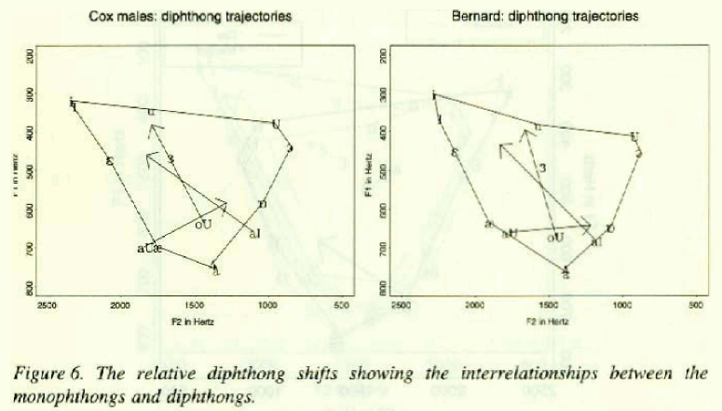

The speaker for this study is female. The data needs some form of normalization, since direct comparison of the formant values is rather meaningless. The normalization technique chosen for this work is to plot the diphthongs against the vowel space described by the monophthongs used in the charts taken from Cox and Panethorpe (2001), see Figure 1. To this end, a second wordlist was recorded using the /h_d/ tokens of Bernard (1969) and Cox (1997). (See Appendix B.)

Since this second wordlist is virtually the same as the one used in the vowel project earlier this quarter, the recordings from that study were leveraged to provide a synchronic comparison with the diphthongs of West Coast American English. As with the comparison with the Bernard and Cox datasets, the comparison is based on the plot of these vowels relative to the vowel space of the speaker.

The recordings for the earlier vowel project were made in the recording booth of the Phonetics lab in Padelford Hall on the University of Washington campus. The equipment used: Electrovoice RE20, Shure FP32A mixer amplifier, “Gambit” iMac, and Sound Studio recording software.

The recordings for this study were made in an empty classroom on the campus of North Seattle Community College. The equipment used: AudioTechnica 4041 condenser microphone placed on a microphone stand and a Microtrack 24.96 digital flash memory recorder. The single-channel recording was sampled at 44,100 Hz and downsampled to 11,025 Hz using Audicity.

Praat was the tool for the acoustic analysis of the recordings. Each recording was manually annotated with a TextGrid, marking the vowel. Parameters for the formant tracker in Praat were established during the manual annotations of the sound files. A Praat script was used to collecct formant data from ten points within each vowel. The script divided the vowel into eleven segments of equal duration. The ten F1 and F2 values were taken at the points between these eleven segments. These values were saved into a text file. The same script was used to collect data from the earlier vowel project records.[2]

In the manual annotation process several interesting phenomena were noted. Figure 2 show a rather curious wave form. The atypical shape of the wave form does not seem to affect the formants, as would be predicted, since the phenomenon is a low-frequency one. Nothing noteworthy was noticed during the recording of this work. Also, there seems to be no audible impact when the sound file is played. It is very curious, though.

Another odd phenomenon is shown in Figure 3. It is a problem with formant tracking that occurred not infrequently in the first wordlist (Appendix A). It was only noted when the vowel in question was word final. It’s rather distressing, since the formant seems to be present, though the formant tracker is “distracted” by higher energy content at higher frequencies. This occurred most often with the [ʊ] off-glide, though it occurs in other contexts as well. In Figure 3, a narrow transcription would be [tuʊ]. This off-glide appears in several of the diphthongs in question, for lexical sets: goat, mouth, and goose with yod on-glide.

To create the plot of the vowel space for the speaker, the plotted monophthongs were analyzed. The plotted monophthongs are: [i ɪ ɛ æ a ɒ ɔ ʊ u]. The corresponding words, as listed in Cox (2001) are: ‘heed’, ‘hid’, ‘head’, ‘had’, ‘hard’, ‘hod’, ‘hoard’, ‘hood’, and ‘who’d’.

**Figure 2: Curious wave form found in data analysis  
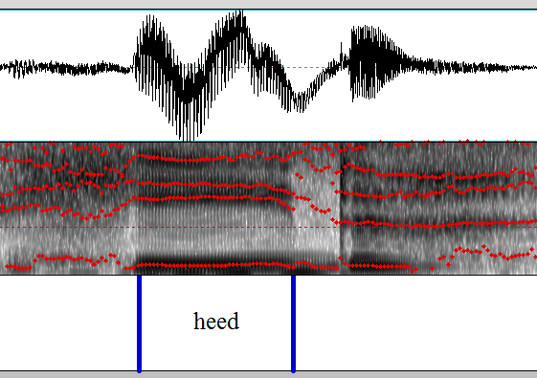**

**Figure 3: Formant tracking problem with a word-final vowel**  
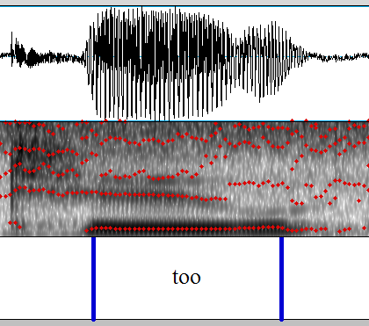

**Figure 4: Sample of Centroid Calculation for Three Monophthongs  
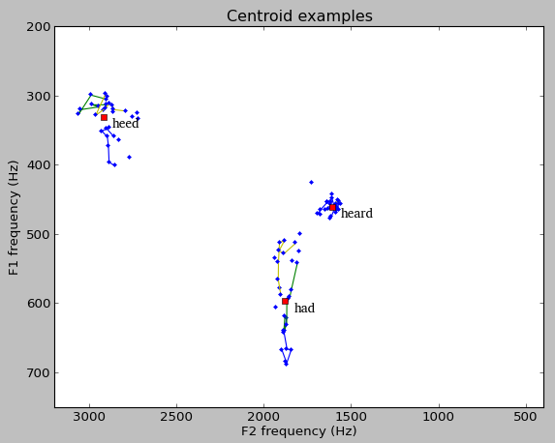**

To arrive at a single point for each monophthong, a point was calculated using the eight central measurements for each vowel in question. The arithmetic mean of the F1 and F2 values for those eight points were used to determine the centroid of the vowel. The first and last points of each of the vowels were excluded as a means of approximating steady state for the vowels.

Figure 4 shows examples of the centroids as calculated for three of the vowels, namely the vowels in lexical sets fleece, trap, and nurse. All ten of the data points are plotted for each instance. The eight used to calculate the centroid are connected by colored lines. The formant deviation from steady state is clearly seen in the ‘heed’ set. In this process, two manual formant measurements were taken to account for problems with formant tracking. This was prompted by visible outliers when checking the calculated centroids using graphing as illustrated in Figure 4. These graphs were generated using the **numpy** and **matplotlib.pyplot** modules for Python 3.2.

**Figure 5: Sample of Centroid Calculations for Diphthongs  
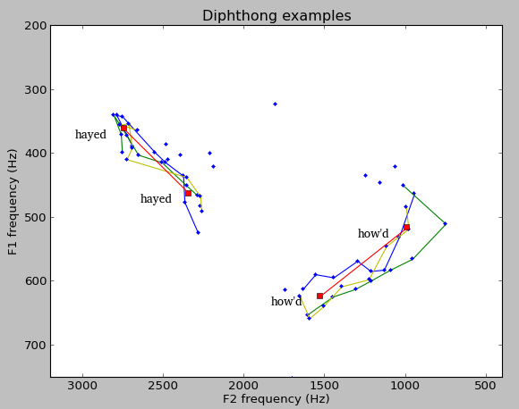**

For the diphthongs, two points are needed, target1 and target2. Once again, using the eight central measurements per token, the first three measurements were used to calculate a centroid for target1 and the last three measurements where used to calculate a centroid for target2. As before the two terminal measurements (the first and last) were excluded from the calculation. These are the points that are most often outliers. This also approximates the one-third / two-thirds measurement points used in the vowel study earlier this quarter. These centroid values center around the 27% and 72% points for the vowel.

Figure 5 gives two samples of the centroid calculations using the diphthongs in lexical sets face and mouth.

Based on these centroids calculations, a vowel chart for the Australian speaker was generated. This is shown in Figure 6.

**Figure 6: Vowel Chart of the Australian Speaker, Denise Brannen**  
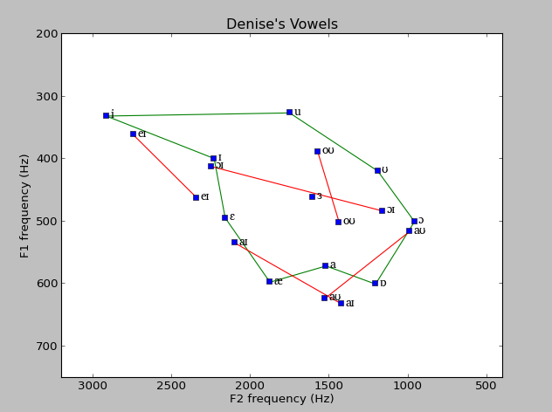

## Discussion

A quick examination of the Figure 6 shows relatively little surface similarity to either of the vowel charts shown in Figure 1. Unfortunately, the specifics of the calculations of the points for the monophthongs and diphthongs used by Bernard (1997) and then by Cox (1996) are unavailable at this time. This makes a comparison with Figure 1 a bit problematic.

For comparison, Figures 7 and 8 show analogously constructed vowel plots for the recordings from the vowel project earlier this quarter. It seems that there are greater superficial similarities with a West Coast American dialect.

Of note in this regard is the location of target1 for the face and mouth diphthongs. In the Australian data, target1 for face is significantly farther back than target1 for mouth.

**Figure 7: Reference plots of American English speaker Jennifer Haywood**   
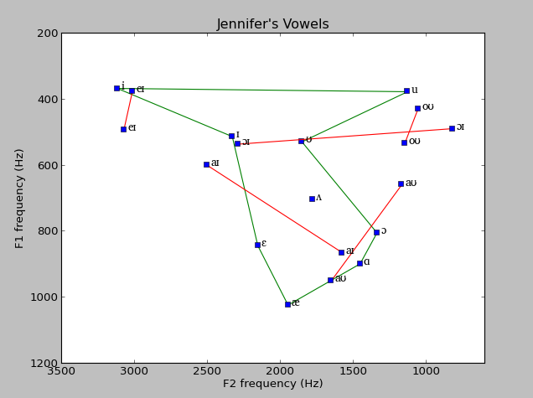

By contrast, these two diphthongs virtually share target1 for the Australian speaker, as well as the two Americans.

Another noteworthy difference is the large distance in both height and backness between [i] and [ɪ]. In the Australian data shown in Figure 1, they almost occupy the same location, particularly in the more recent Cox (1997) plots. By contrast, the speakers lax and tense high front vowels are clearly separated.

Another interesting point in Figure 6 is the rather high [a] vowel. This one may be ascribed to introduction of rhoticity in the word ‘hard’.

All of these may be viewed as accommodation to a West Coast American pronunciation.

On the other hand, there are some very clear distinctions between Figure 6 and Figures 7 and 8. The location of [u] and [oʊ] are both central, where they are quite back in

**Figure 8: Reference plots of American English speaker Dan Jinguji**  
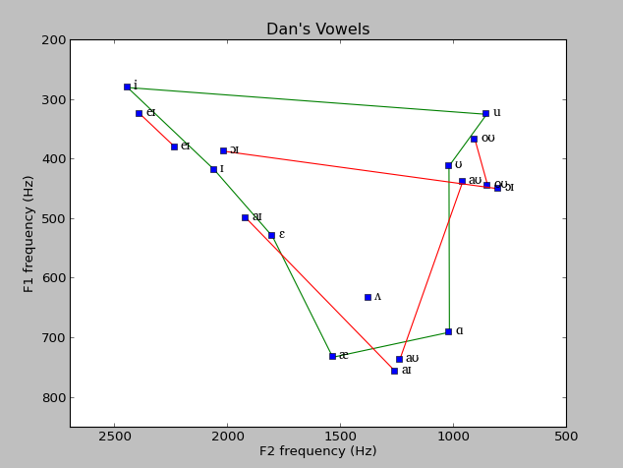

both Figures 7 and 8. This central location for these vowels mirrors the placement seen in Figure 1.

These similarities between Figure 6 and Figures 7 and 8 could easily be accounted for as accommodation to the regional dialect, particularly given filial pressure to conform. There are still strong bits of evidence of the original Australian vowel system, as noted in the central location of [u] and [oʊ]. Indeed, the general subjective perception of the subject’s speech is one of Australian dialect.

Unfortunately, the difficulties with the formant tracker in Praat combined with the time restrictions did not permit much analysis of the first word-set for this study. A preliminary look at the diphthongs did show considerable variation in the placement of target1 and target2 for these diphthongs. This is consistent with the idea that has been put forth that one of the most salient features of diphthongs is the relative movement of the formants, rather than their precise placement within the vowel space. This would be an interesting aspect of perception to follow, were time to permit.

## References

Blunt, Jerry. 1980. *More Stage Dialects*, Dramatic Publishing Co.

Cox, Felicity and Sallyanne Palethorpe. 2001. ‘The changing face of Australian English vowels’ in *English in Australia*, David Blair and Peter Collins (eds), John Benjamens Publishing. p17-44.

Horvath, Barbara M. 1985. *Variation in Australian English*. Cambridge University Press.

Wells, J.C. 1982. *Accents of English*, vols. 1 & 3. Cambridge University Press.

## Appendix A: Initial Word List

law whose sash bit ask shoot  
 give whose stitch dot huge chow  
 eight choice tide use shout view  
 eight use chow day shoot stitch  
 toad ask oyster bit half use  
 die dot show give view too  
 cat toad toy tide give pause  
 math huge cat half chow tide  
 shout choice toy out stayed too  
 shout die show oyster ice view  
 eight ice oyster stayed task oats  
 ice show day out stitch task  
 out huge shoot oats stayed math  
 choice die oats sash day law  
 toad half toy sash cat pause  
 bit whose ask math too dot  
 law pause task done

## Appendix B: Word List based on work of Bernard (1967) and Cox (1996)

heed heed heed hid hid hid  
 head head head had had had  
 hard hard hard hud hud hud  
 hod hod hod hoard hoard hoard  
 hood hood hood who’d who’d who’d  
 hawed hawed hawed heard heard heard  
 heered heered heered haired haired haired  
 hayed hayed hayed hide hide hide  
 hoyd hoyd hoyd hoed hoed hoed  
 how’d how’d how’d done

1. These primary sources are available through WorldCat, though the only copies listed are physically in Australia. The scope and timeline for this term project didn't warrant the inter-library loan request.
2. The discrepancies in formant values earlier reported in the write-up for the vowel project came from differences in the Dynamic Range setting for the built-in Praat formant tracker (30 Hz) and the value used in the script (50 Hz) which was taken from the literature.